Lab2 :

Lab3 : 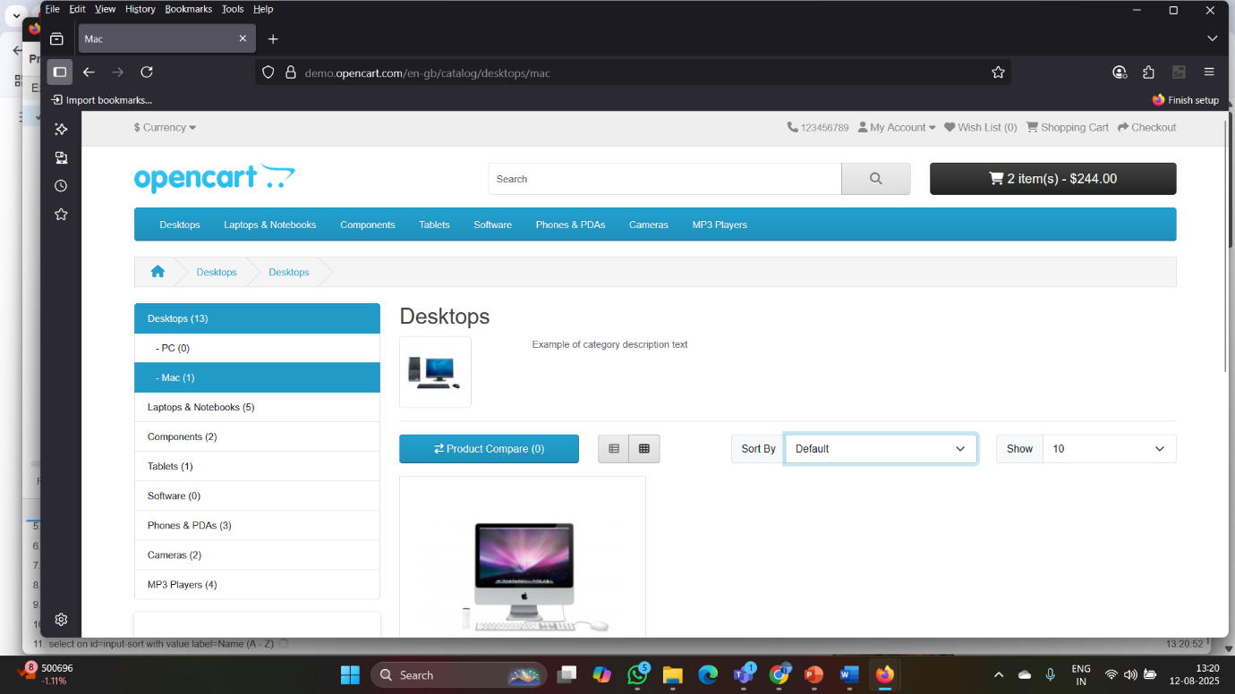

Lab 4:

